Week 8 Lab: Database Auditing

Patching decisions involve a genuine trade-off between security posture and operational continuity. The case for applying patches promptly is well established: unpatched systems account for a significant share of exploited vulnerabilities in database breaches, and regulatory frameworks including PCI-DSS and HIPAA require organisations to maintain current patch levels as a baseline control (NIST 2024). Figure 1 shows the Horizon VM running Windows 11 Version 23H2 with the most recent cumulative update installed on 8/21/2025, confirming the OS is actively maintained. The risk of not patching is concrete, in the sense that known CVEs with published exploit code give attackers a reliable, low-effort entry point that no network or application-layer control can fully compensate for. The case against immediate patch deployment is equally practical in production environments: patches can introduce regression errors in stored procedures, alter driver compatibility, or require service restarts that break high-availability configurations (Microsoft 2023). In shared environments such as the Horizon VM used in this course, a patch applied by one user affects every other user on the same instance, which means patching decisions carry institutional rather than individual consequences. The balanced approach is a staged deployment process: test in a non-production environment, validate application compatibility, schedule maintenance windows, and document rollback procedures before applying to production.
Database auditing events typically fall into four categories. Authentication events cover successful and failed logins; Figure 5 shows both in the SQL Server current log, with DU\Grace.Luhanga login successes alongside a failed login for fakeuser with error 18456, Severity 14. Privilege and permission events cover GRANT, REVOKE, and DENY statements

that change what users can do. Schema change events cover DDL operations including CREATE, ALTER, and DROP on tables, indexes, views, and stored procedures, which matter for change management and accountability. Data access events cover SELECT, INSERT, UPDATE, and DELETE on sensitive objects, which is what the database-level audit specification created in Part 9 captures by targeting specific tables and principals. Together these four categories satisfy the audit trail requirements common to SOC 2, HIPAA, and GDPR compliance assessments (NIST 2024).
The most important thing I wish I had known before starting this lab is that enabling login auditing in Server Properties does not take effect until the SQL Server service is fully restarted. The lab makes this explicit, but it is easy to underestimate that exiting and reopening SSMS does not restart the service, and without the restart the login events generated in Part 6 will not appear in the log. The second thing worth knowing upfront is that the server-level audit must be created and enabled before the database-level audit specification will work; the specification references the server audit by name, so the order of operations matters. I also wish I had known that the Log File Viewer displays events in reverse chronological order by default, which means the most recent events appear at the top and the server startup entries from the restart are visible further down the list, as shown in Figure 5.

Figure 1: Windows Update history – Horizon VM running Windows 11 Version 23H2, most recent cumulative
update installed 8/21/2025
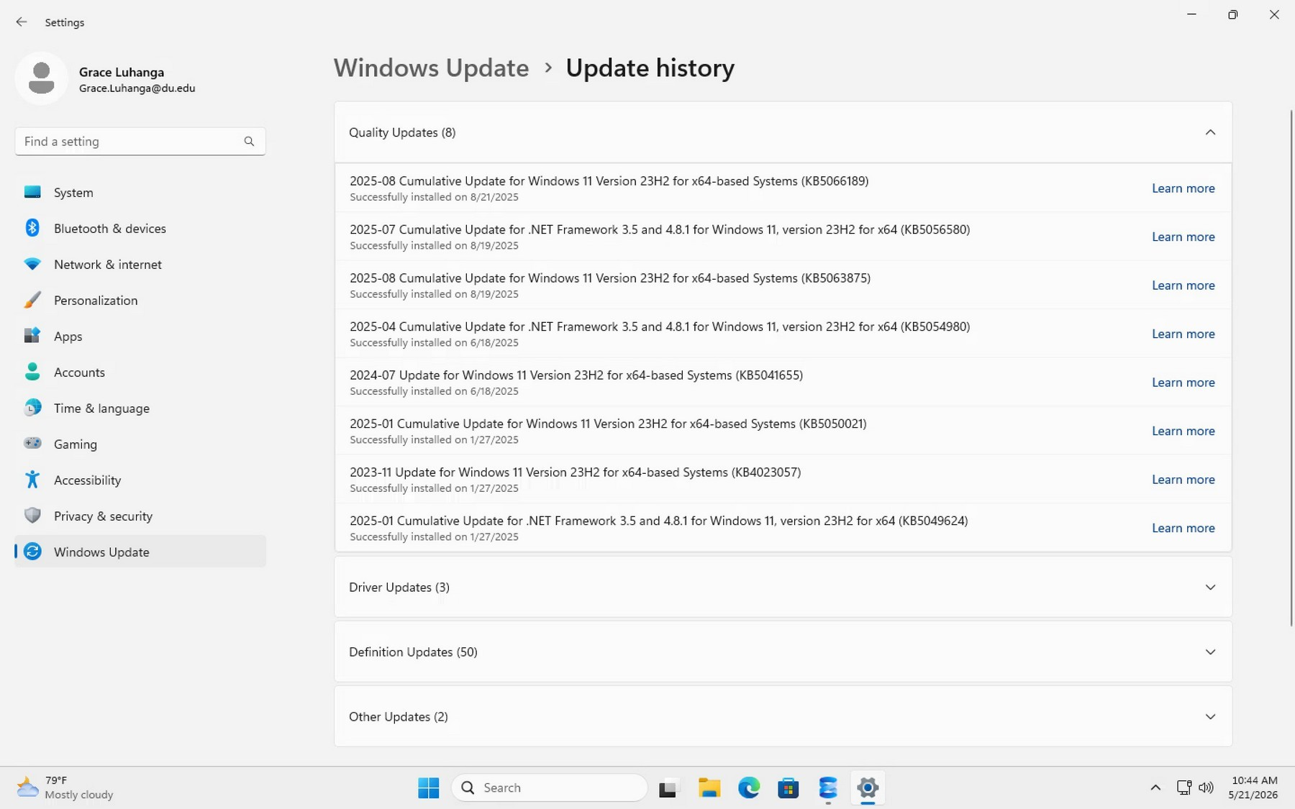

Figure 2: SELECT @@VERSION – Microsok SQL Server 2025 (RTM) 17.0.1000.7 (X64) confirmed on the Horizon
instance
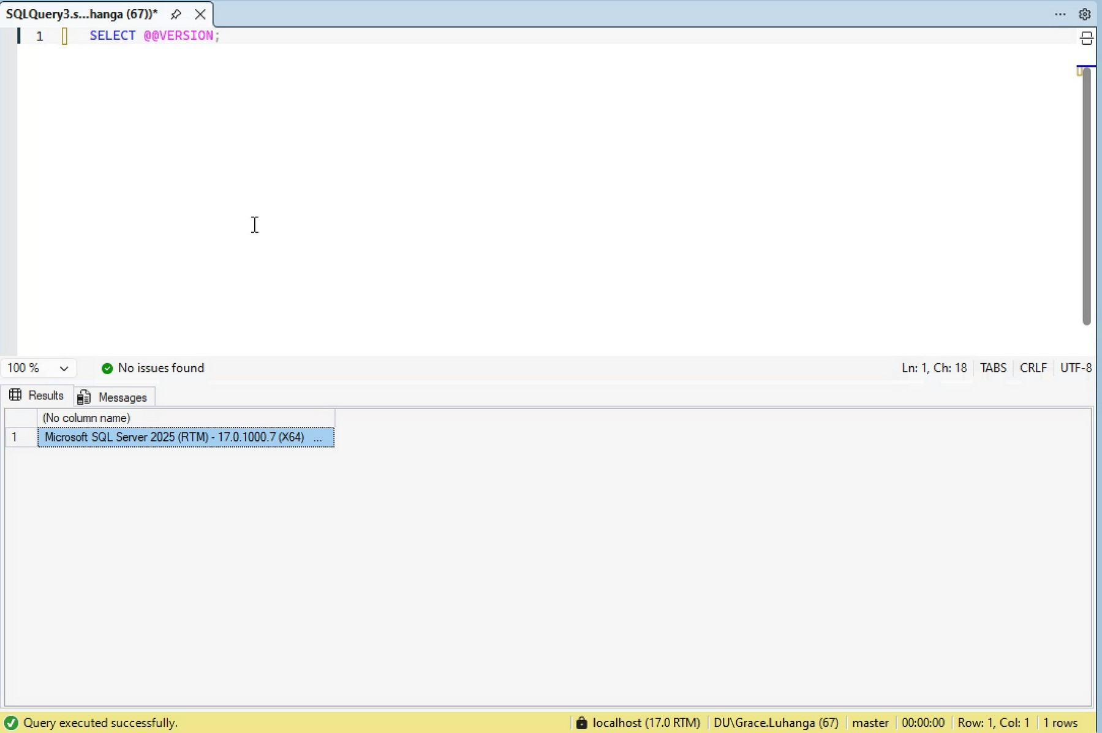

Figure 3: SQL Server current log – startup events including authentication mode, memory allocation, and database recovery entries from 4/6/2026
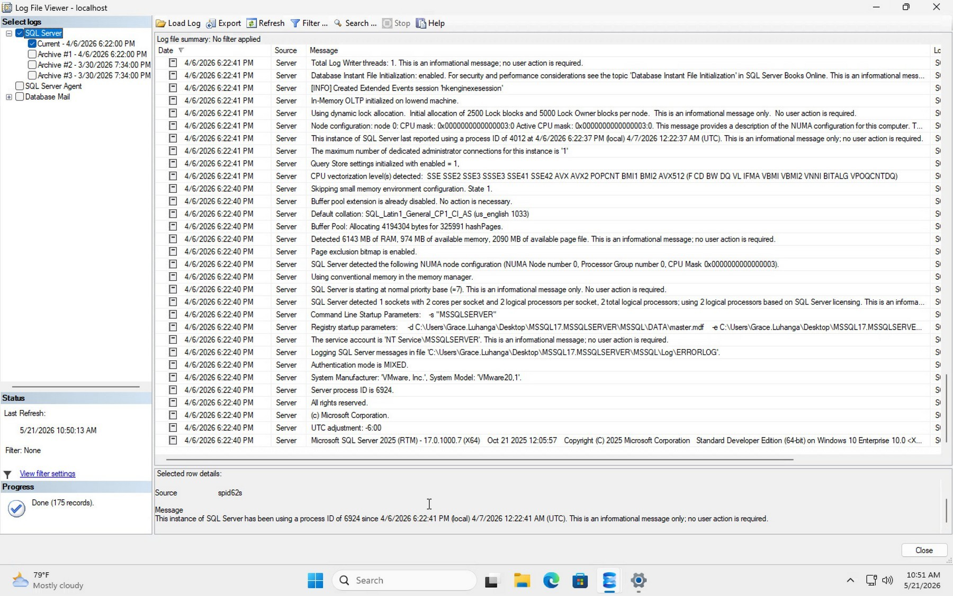

Figure 4: Server Properties Security page – login auditing set to Both failed and successful logins
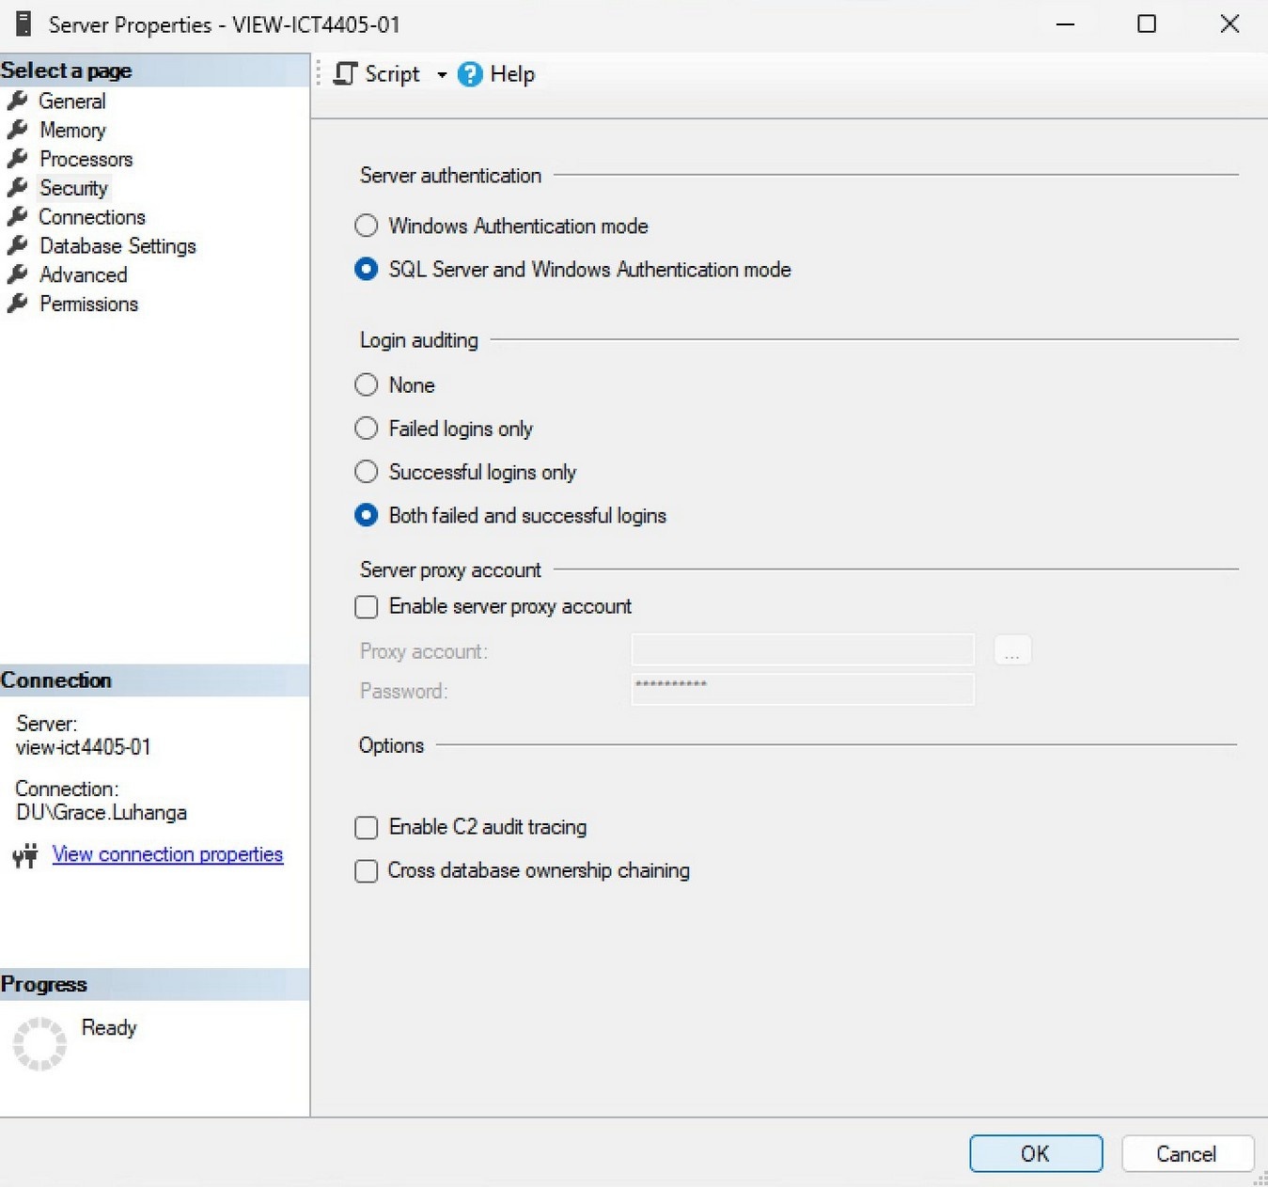

Figure 5: SQL Server current log aker restart – successful logins for DU\Grace.Luhanga and failed login for fakeuser (Error 18456, Severity 14) confirmed
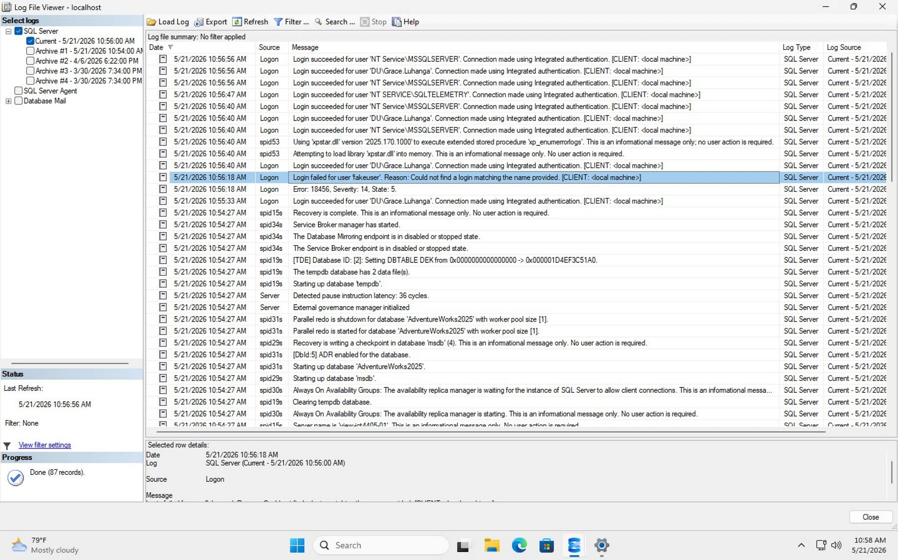

Figure 6: Database Audit Specification enabled successfully – MyDatabaseAuditSpec activated against MyServerAudit on AdventureWorks2025
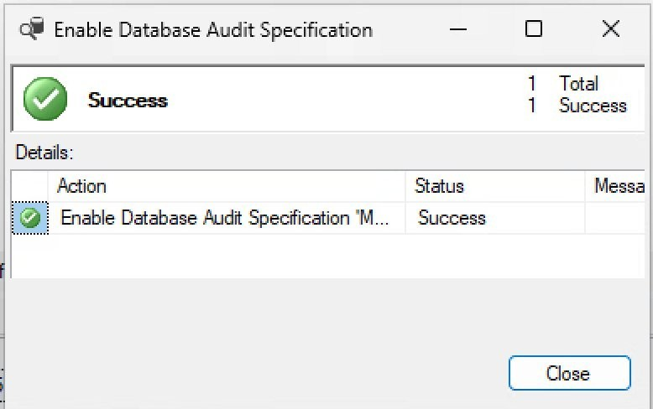

References

Microsoft. (2023). “SQL Server auditing (database engine).” Accessed May 21, 2026. https://learn.microsoft.com/en-us/sql/relational-databases/security/auditing/sql-server-audit-database-engine?view=sql-server-ver17
NIST. (2024). “SP 800-53 Rev. 5: Security and privacy controls for information systems and organizations.” Accessed May 21, 2026. https://csrc.nist.gov/publications/detail/sp/800-53/rev-5/final

